**LAB 7**

**Static Routing**

**Aims:**

Static routing in Cisco Packet Tracer aims to provide a simple and manually configured method for directing network traffic between routers by defining specific routes in the routing table. Unlike dynamic routing protocols that automatically adapt to network changes, static routing requires network administrators to manually input and maintain routing information. This method is suitable for small to medium-sized networks with relatively stable topologies, where the simplicity of configuration outweighs the need for automatic route adjustments. Static routing can enhance network security by reducing the attack surface associated with dynamic routing protocols, making it a preferred choice in certain scenarios where predictability and control over routing decisions are critical.

**Introduction:**

Static routing is a simple method of network routing in which network administrators manually configure routing tables on routers or switches. Static routing involves manually configuring the routing tables on network devices, specifying the paths that data packets should take to reach their destination. It is employed in scenarios where the network parameters and environment are expected to remain constant.

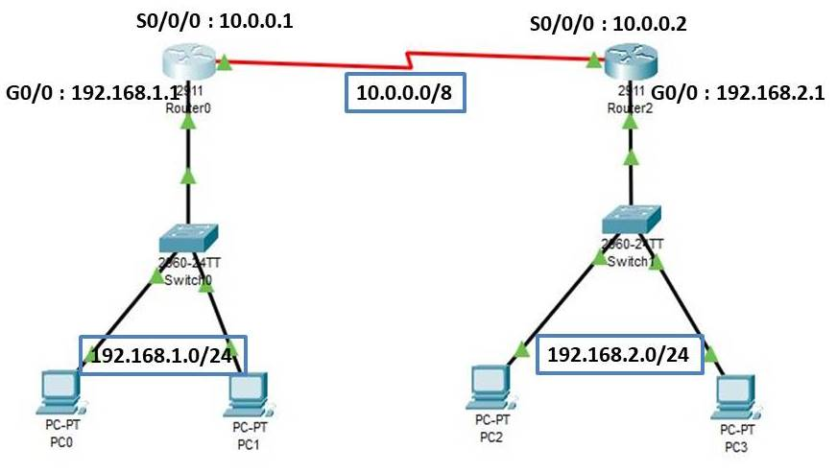

**Advantages:**

* Static routing causes very little load on the [CPU](https://en.wikipedia.org/wiki/CPU) of the router, and produces no traffic to other routers.
* Static routing leaves the network administrator with full control over the routing behavior of the network.
* Static Routing is very easy to configure on small networks.

**Difference between Static and Dynamic Routing:**

|  |  |  |
| --- | --- | --- |
| **S.N** | **Static Routing** | **Dynamic Routing** |
| **1.** | In static routing routes are user-defined. | In dynamic routing, routes are updated according to the topology. |
| **2.** | Static routing does not use complex routing algorithms. | Dynamic routing uses complex routing algorithms. |
| **3.** | Static routing provides high or more security. | Dynamic routing provides less security. |
| **4.** | Static routing is manual. | Dynamic routing is automated. |
| **5.** | Static routing is implemented in small networks. | Dynamic routing is implemented in large networks. |
| **6.** | In static routing, failure of the link disrupts the rerouting. | In dynamic routing, failure of the link does not interrupt the rerouting. |
| **7.** | Static Routing is difficult to configure. | Dynamic Routing is easy to configure. |
| **8.** | In static routing, additional resources are not required. | In dynamic routing, additional resources are required. |
| **9.** | Less Bandwidth is required in Static Routing. | More Bandwidth is required in Dynamic Routing. |
| **10.** | Another name for static routing is non-adaptive routing. | Another name for dynamic routing is adaptive routing. |

**Design a static routing using cisco packet tracer:**

**Step1:** First select and insert four routers (1841), four switches (2960) and 2 pcs for each switches and name them as shown below.

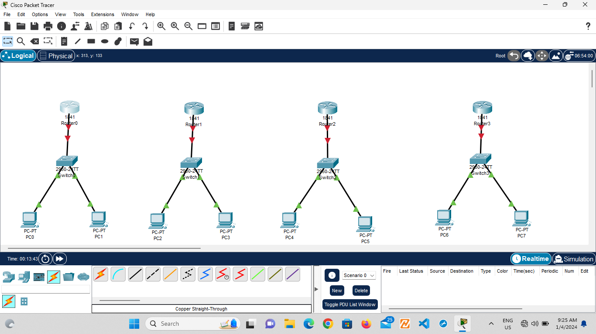

**Step 2:** Configure IPV4 address and subnet mask for each pcs.

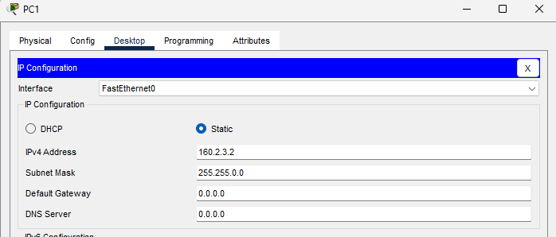

**Step 3:** Before connecting each devices, we have to change the physical view of the router.

* Go to physical.
* Turn off the router.
* Click on WIC-2T and insert it into the router by dragging.

Repeat the same steps for each router.

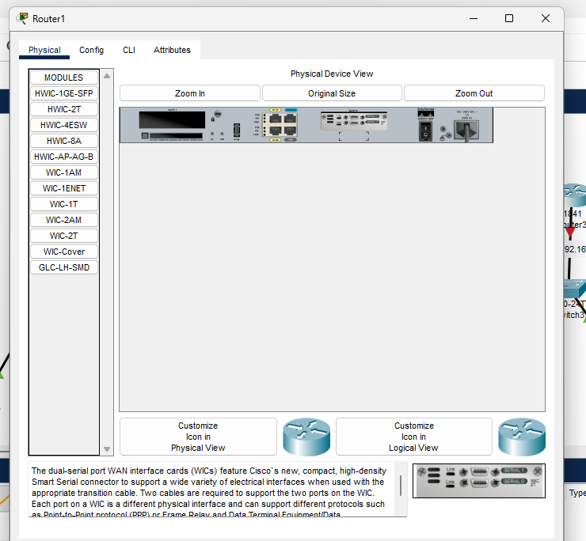

**Step 4:** Connect the devices as below

* Switch and Router using copper straight through cable.
* Router and Router using serial DTE cable.
* Switch and PCs using copper straight through cable.

And name them as shown below:

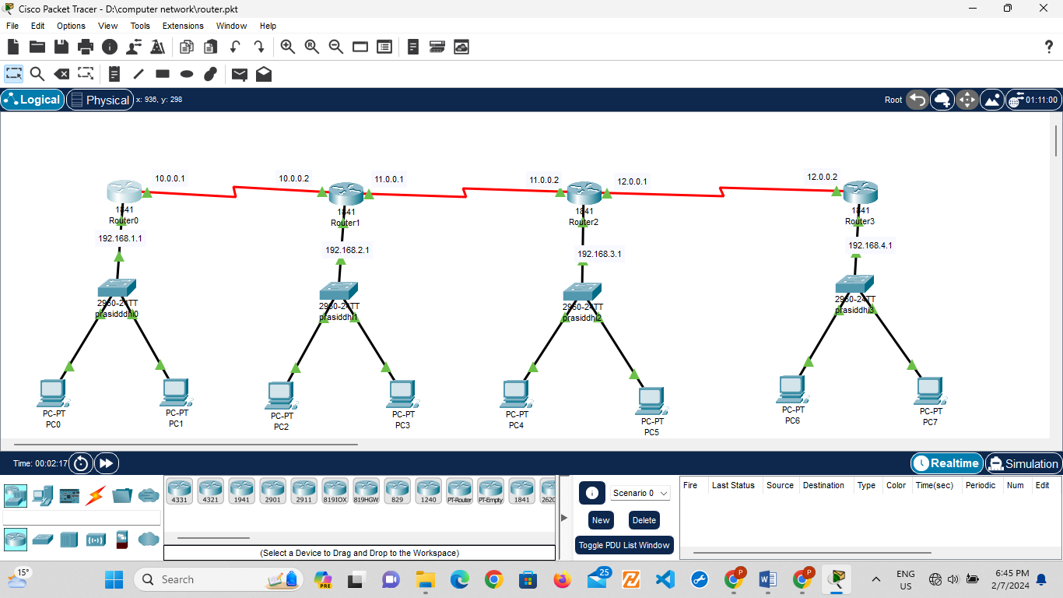

**Step 5:** now, we have to assign an IP address in each router as below:

Router>en

Router#configure terminal

Router(config)#int f0/0

Router(config-if)#ip address 192.168.1.1 255.255.255.0

Router(config-if)#no shutdown

Router(config-if)#exit

Router(config)#int s0/0/0

Router(config-if)#ip address 10.0.0.1 255.0.0.0

Router(config-if)#no shutdown

Router(config-if)#exit

Repeat the same process for each router using the different ip address connecting with the router.

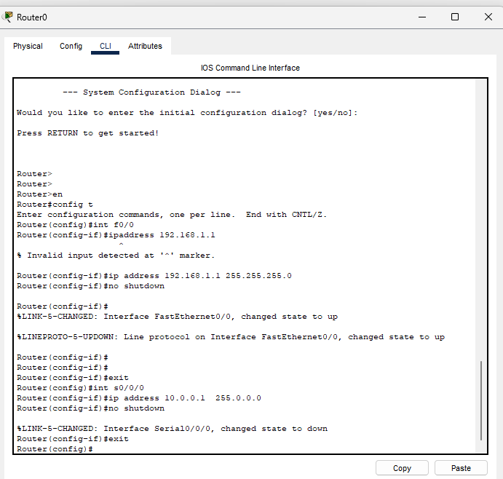

**Step 6:** Again configure static routes into the router as below:

Router(config)#ip route 192.168.2.0 255.255.255.0 10.0.0.2

Router(config)#ip route 192.168.3.0 255.255.255.0 10.0.0.2

Router(config)#ip route 192.168.4.0 255.255.255.0 10.0.0.2

Router(config)#ip route 11.0.0.0 255.0.0.0 10.0.0.2

Router(config)#ip route 12.0.0.0 255.0.0.0 10.0.0.2

Router(config)#exit

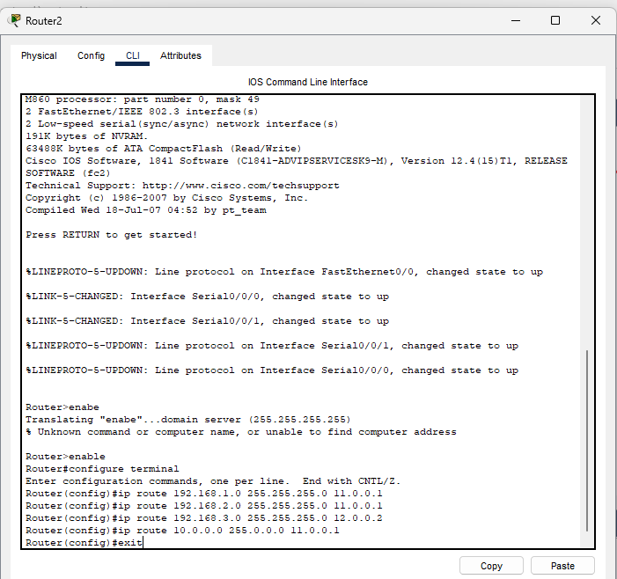

**Step 7:** Verify the network by pinging the ip address of any PC. First, click on PC1 then Go to the command prompt then type ping <IP address of targeted node>

As we can see in the below image we are getting replies which means the connection is working very fine.

Pinging 192.168.4.3 from PC0.

